BÀI THỰC HÀNH TUẦN 3 LAB 7
Họ và tên: Đặng Đình An

Lớp 11_THMT

MSSV:1150080001

MainActivity.java
package com.example.lap7th3;
import android.content.Intent;
import android.os.Bundle;
import android.widget.Button;
import androidx.appcompat.app.AppCompatActivity;
public class MainActivity extends AppCompatActivity {
Button btnBai1, btnBai2, btnBai3;
@Override
protected void onCreate(Bundle savedInstanceState) {
super.onCreate(savedInstanceState);
setContentView(R.layout.activity_main);
btnBai1 = findViewById(R.id.btnBai1);
btnBai2 = findViewById(R.id.btnBai2);
btnBai3 = findViewById(R.id.btnBai3);
btnBai1.setOnClickListener(v ->
startActivity(new Intent(MainActivity.this, Bai1Activity.class))
);
btnBai2.setOnClickListener(v ->
startActivity(new Intent(MainActivity.this, Bai2Activity.class))
);
btnBai3.setOnClickListener(v ->
startActivity(new Intent(MainActivity.this, CustomActivity.class))
);
}
}

activity_main
<?xml version="1.0" encoding="utf-8"?>
<LinearLayout xmlns:android="http://schemas.android.com/apk/res/android"
android:orientation="vertical"
android:gravity="center"
android:padding="20dp"
android:layout_width="match_parent"
android:layout_height="match_parent">
<Button
android:id="@+id/btnBai1"
android:layout_width="200dp"
android:layout_height="60dp"
android:text="Bài 1 - Custom Button" />
<Button
android:id="@+id/btnBai2"
android:layout_width="200dp"
android:layout_height="60dp"
android:layout_marginTop="20dp"
android:text="Bài 2 - Toast + Dialog" />
<Button
android:id="@+id/btnBai3"
android:layout_width="200dp"
android:layout_height="60dp"
android:layout_marginTop="20dp"
android:text="Bài 3 - RGB + CMY" />
</LinearLayout>
Kết quả
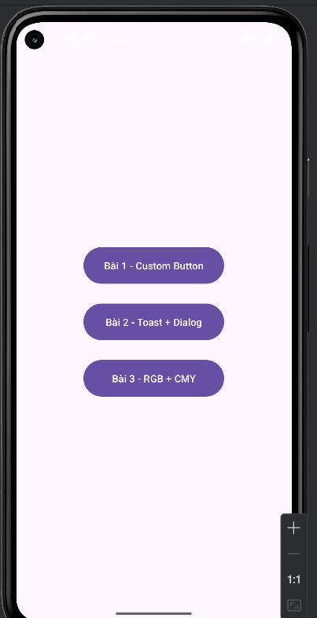

Bai1Activity.java
package com.example.lap7th3;
import android.graphics.Color;
import android.os.Bundle;
import android.widget.Button;
import android.widget.ImageView;
import androidx.appcompat.app.AppCompatActivity;
public class Bai1Activity extends AppCompatActivity {
Button btnRed, btnGreen;
ImageView imgFace;
@Override
protected void onCreate(Bundle savedInstanceState) {
super.onCreate(savedInstanceState);
setContentView(R.layout.activity_bai1);
btnRed = findViewById(R.id.btnRed);
btnGreen = findViewById(R.id.btnGreen);
imgFace = findViewById(R.id.imgFace);
// Màu đỏ
btnRed.setOnClickListener(v ->
imgFace.setColorFilter(Color.RED)
);
// Màu xanh lá
btnGreen.setOnClickListener(v ->
imgFace.setColorFilter(Color.GREEN)
);
}
}
activity_bai1.xml
<?xml version="1.0" encoding="utf-8"?>
<LinearLayout xmlns:android="http://schemas.android.com/apk/res/android"
android:orientation="vertical"
android:gravity="center"
android:padding="20dp"
android:layout_width="match_parent"
android:layout_height="match_parent">
<Button
android:id="@+id/btnRed"
android:layout_width="200dp"
android:layout_height="60dp"
android:text="BUTTON RED"
android:textColor="#FFF"
android:background="@drawable/btn_red"
android:textStyle="bold" />
<Button
android:id="@+id/btnGreen"
android:layout_width="200dp"
android:layout_height="60dp"
android:layout_marginTop="20dp"
android:text="BUTTON GREEN"
android:textColor="#FFF"
android:background="@drawable/btn_green"
android:textStyle="bold" />
<!-- Ảnh mặt cười -->
<ImageView
android:id="@+id/imgFace"
android:layout_width="150dp"
android:layout_height="150dp"
android:layout_marginTop="40dp"
android:src="@drawable/face_transparent" />
</LinearLayout>
Kết quả
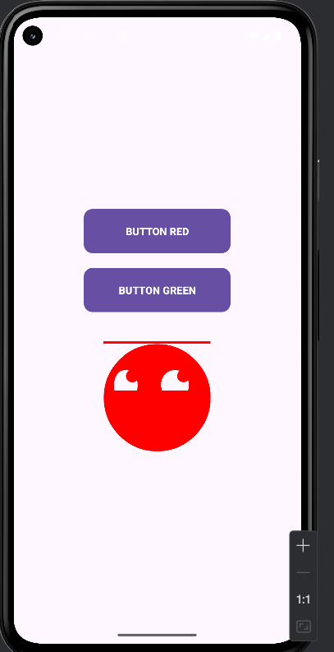

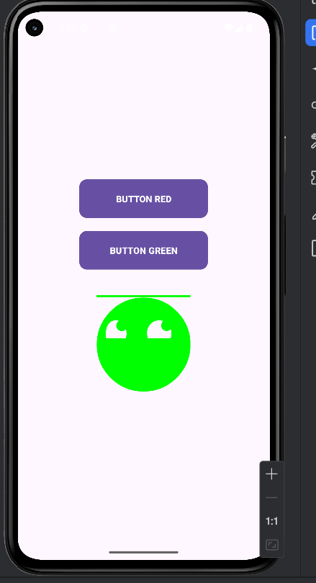

Bai2Activity.java
package com.example.lap7th3;
import android.app.Dialog;
import android.os.Bundle;
import android.view.Gravity;
import android.view.LayoutInflater;
import android.view.View;
import android.widget.Button;
import android.widget.Toast;
import androidx.appcompat.app.AppCompatActivity;
public class Bai2Activity extends AppCompatActivity {
Button btnToast, btnDialog;
@Override
protected void onCreate(Bundle savedInstanceState) {
super.onCreate(savedInstanceState);
setContentView(R.layout.activity_bai2);
btnToast = findViewById(R.id.btnToast);
btnDialog = findViewById(R.id.btnDialog);
// Custom Toast
btnToast.setOnClickListener(v -> {
LayoutInflater inflater = getLayoutInflater();
View layout = inflater.inflate(R.layout.custom_toast, null);
Toast toast = new Toast(getApplicationContext());
toast.setGravity(Gravity.CENTER, 0, 0);
toast.setDuration(Toast.LENGTH_LONG);
toast.setView(layout);
toast.show();
});
// Custom Dialog
btnDialog.setOnClickListener(v -> {
final Dialog dialog = new Dialog(Bai2Activity.this);
dialog.setContentView(R.layout.custom_dialog);
dialog.getWindow().setBackgroundDrawableResource(android.R.color.transparent);
Button btnOk = dialog.findViewById(R.id.btnOk);
Button btnClose = dialog.findViewById(R.id.btnCloseDialog);
btnClose.setOnClickListener(view -> dialog.dismiss());
btnOk.setOnClickListener(view -> {
// Có thể xử lý đăng nhập ở đây
Toast.makeText(Bai2Activity.this, "Đăng nhập thành công!", Toast.LENGTH_SHORT).show();
dialog.dismiss();
});
dialog.show();
});
}
}
activity_bai2.xml
<?xml version="1.0" encoding="utf-8"?>
<LinearLayout xmlns:android="http://schemas.android.com/apk/res/android"
android:layout_width="match_parent"
android:layout_height="match_parent"
android:orientation="vertical"
android:gravity="center"
android:padding="16dp"
android:background="#E3F2FD">
<TextView
android:layout_width="wrap_content"
android:layout_height="wrap_content"
android:text="DrawableExample"
android:textSize="24sp"
android:textStyle="bold"
android:layout_marginBottom="40dp" />
<LinearLayout
android:layout_width="wrap_content"
android:layout_height="wrap_content"
android:orientation="horizontal"
android:gravity="center"
android:layout_marginBottom="50dp">
<!-- Button TOAST - ĐÃ SỬA -->
<Button
android:id="@+id/btnToast"
android:layout_width="120dp"
android:layout_height="60dp"
android:text="TOAST"
android:textColor="@android:color/white"
android:backgroundTint="#1976D2"
android:layout_marginEnd="20dp" />
<!-- Button DIALOG - ĐÃ SỬA -->
<Button
android:id="@+id/btnDialog"
android:layout_width="120dp"
android:layout_height="60dp"
android:text="DIALOG"
android:textColor="@android:color/white"
android:backgroundTint="#1976D2" />
</LinearLayout>
<TextView
android:layout_width="wrap_content"
android:layout_height="wrap_content"
android:text="Made by Thái Duy Quý"
android:textSize="16sp"
android:textColor="#555555" />
</LinearLayout>
Kết quả
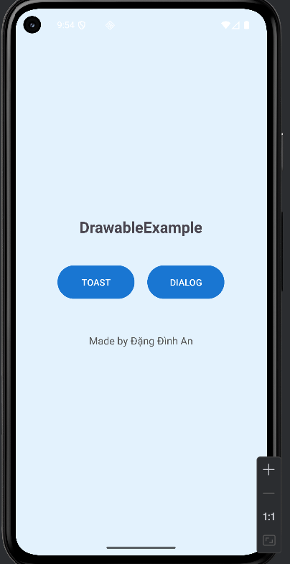
custom_toast
<?xml version="1.0" encoding="utf-8"?>
<LinearLayout xmlns:android="http://schemas.android.com/apk/res/android"
android:layout_width="wrap_content"
android:layout_height="wrap_content"
android:orientation="horizontal"
android:background="@drawable/toast_background"
android:padding="16dp"
android:gravity="center_vertical">
<TextView
android:id="@+id/txtMsg"
android:layout_width="wrap_content"
android:layout_height="wrap_content"
android:text="Custom Toast, made by Đình An ❤️"
android:textColor="#FFFFFF"
android:textSize="18sp"
android:layout_marginStart="12dp"/>
</LinearLayout>
Kết quả
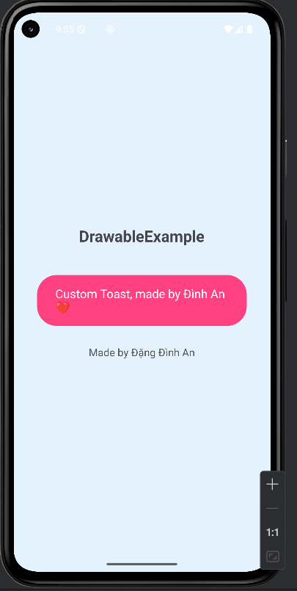

custom_dialog.xml
<?xml version="1.0" encoding="utf-8"?>
<LinearLayout xmlns:android="http://schemas.android.com/apk/res/android"
android:layout_width="300dp"
android:layout_height="wrap_content"
android:orientation="vertical"
android:background="@drawable/dialog_background"
android:padding="20dp">
<TextView
android:layout_width="wrap_content"
android:layout_height="wrap_content"
android:text="Đăng nhập"
android:textSize="22sp"
android:textStyle="bold"
android:textColor="#1976D2"
android:layout_gravity="center"
android:layout_marginBottom="20dp"/>
<EditText
android:id="@+id/edtUsername"
android:layout_width="match_parent"
android:layout_height="wrap_content"
android:hint="Tài khoản"
android:backgroundTint="#666666"
android:drawableStart="@android:drawable/ic_menu_myplaces"
android:drawablePadding="8dp"/>
<EditText
android:id="@+id/edtPassword"
android:layout_width="match_parent"
android:layout_height="wrap_content"
android:hint="Mật khẩu"
android:inputType="textPassword"
android:layout_marginTop="10dp"
android:backgroundTint="#666666"
android:drawableStart="@android:drawable/ic_lock_lock"
android:drawablePadding="8dp"/>
<LinearLayout
android:layout_width="match_parent"
android:layout_height="wrap_content"
android:orientation="horizontal"
android:gravity="center"
android:layout_marginTop="20dp">
<!-- Button THOÁT - ĐÃ SỬA -->
<Button
android:id="@+id/btnCloseDialog"
android:layout_width="wrap_content"
android:layout_height="wrap_content"
android:text="THOÁT"
android:textColor="@android:color/white"
android:backgroundTint="#F44336"
android:layout_marginEnd="20dp"/>
<!-- Button ĐỒNG Ý - ĐÃ SỬA -->
<Button
android:id="@+id/btnOk"
android:layout_width="wrap_content"
android:layout_height="wrap_content"
android:text="ĐỒNG Ý"
android:textColor="@android:color/white"
android:backgroundTint="#4CAF50"/>
</LinearLayout>
</LinearLayout>
Kết quả
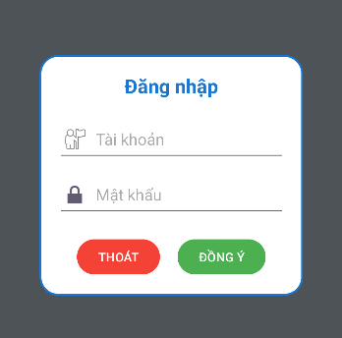

CustomActivity.java
package com.example.lap7th3;
import android.app.AlertDialog;
import android.graphics.Color;
import android.os.Bundle;
import android.view.LayoutInflater;
import android.view.View;
import android.widget.*;
import androidx.appcompat.app.AppCompatActivity;
public class CustomActivity extends AppCompatActivity {
Button btnCustom, btnToast, btnDialog;
SeekBar seekR, seekG, seekB;
View colorPreview;
TextView tvCMY;
@Override
protected void onCreate(Bundle savedInstanceState) {
super.onCreate(savedInstanceState);
setContentView(R.layout.activity_custom);
btnCustom = findViewById(R.id.btnCustom);
btnToast = findViewById(R.id.btnToast);
btnDialog = findViewById(R.id.btnDialog);
seekR = findViewById(R.id.seekR);
seekG = findViewById(R.id.seekG);
seekB = findViewById(R.id.seekB);
colorPreview = findViewById(R.id.colorPreview);
tvCMY = findViewById(R.id.tvCMY);
btnToast.setOnClickListener(v -> showCustomToast("Đây là Custom Toast!"));
btnDialog.setOnClickListener(v -> showCustomDialog());
SeekBar.OnSeekBarChangeListener listener = new SeekBar.OnSeekBarChangeListener() {
@Override public void onProgressChanged(SeekBar seekBar, int progress, boolean fromUser) {
updateColorPreview();
}
@Override public void onStartTrackingTouch(SeekBar seekBar) { }
@Override public void onStopTrackingTouch(SeekBar seekBar) { }
};
seekR.setOnSeekBarChangeListener(listener);
seekG.setOnSeekBarChangeListener(listener);
seekB.setOnSeekBarChangeListener(listener);
seekR.setProgress(100);
seekG.setProgress(150);
seekB.setProgress(200);
updateColorPreview();
}
private void showCustomToast(String msg) {
View layout = getLayoutInflater().inflate(R.layout.layout_custom_toast, null);
TextView tv = layout.findViewById(R.id.tvToast);
tv.setText(msg);
Toast toast = new Toast(getApplicationContext());
toast.setDuration(Toast.LENGTH_SHORT);
toast.setView(layout);
toast.show();
}
private void showCustomDialog() {
AlertDialog.Builder builder = new AlertDialog.Builder(this);
View view = getLayoutInflater().inflate(R.layout.layout_custom_dialog, null);
builder.setView(view);
AlertDialog dialog = builder.create();
Button ok = view.findViewById(R.id.btnDialogOk);
Button cancel = view.findViewById(R.id.btnDialogCancel);
ok.setOnClickListener(v -> {
showCustomToast("Bạn đã chọn OK");
dialog.dismiss();
});
cancel.setOnClickListener(v -> dialog.dismiss());
dialog.show();
}
private void updateColorPreview() {
int r = seekR.getProgress();
int g = seekG.getProgress();
int b = seekB.getProgress();
int color = Color.rgb(r, g, b);
colorPreview.setBackgroundColor(color);
int c = 255 - r;
int m = 255 - g;
int y = 255 - b;
tvCMY.setText(
String.format("RGB(%d, %d, %d) → CMY(%d, %d, %d)", r, g, b, c, m, y)
);
}
}
activity_custom.xml
<?xml version="1.0" encoding="utf-8"?>
<ScrollView xmlns:android="http://schemas.android.com/apk/res/android"
android:layout_width="match_parent"
android:layout_height="match_parent"
android:padding="20dp"
android:fitsSystemWindows="true"
android:background="#F4F4F4">
<LinearLayout
android:orientation="vertical"
android:layout_width="match_parent"
android:layout_height="wrap_content"
android:gravity="center_horizontal">
<!-- CUSTOM BUTTON -->
<Button
android:id="@+id/btnCustom"
android:layout_width="wrap_content"
android:layout_height="wrap_content"
android:text="Custom Button"
android:textColor="#FFF"
android:paddingLeft="30dp"
android:paddingRight="30dp"
android:background="@drawable/bg_custom_button"
android:textStyle="bold"
android:layout_marginBottom="20dp"/>
<!-- COLOR PREVIEW BOX -->
<View
android:id="@+id/colorPreview"
android:layout_width="200dp"
android:layout_height="120dp"
android:layout_marginBottom="10dp"
android:background="@drawable/bg_preview_box"/>
<TextView
android:id="@+id/tvCMY"
android:layout_width="wrap_content"
android:layout_height="wrap_content"
android:text="RGB → CMY"
android:textSize="16sp"
android:textStyle="bold"
android:layout_marginBottom="20dp"/>
<!-- SEEK R -->
<SeekBar
android:id="@+id/seekR"
android:layout_width="match_parent"
android:layout_height="wrap_content"
android:max="255"
android:progressDrawable="@drawable/seek_red_progress"
android:thumb="@drawable/custom_thumb"/>
<!-- SEEK G -->
<SeekBar
android:id="@+id/seekG"
android:layout_width="match_parent"
android:layout_height="wrap_content"
android:max="255"
android:progressDrawable="@drawable/custom_seekbar_progress"
android:thumb="@drawable/custom_thumb"/>
<!-- SEEK B -->
<SeekBar
android:id="@+id/seekB"
android:layout_width="match_parent"
android:layout_height="wrap_content"
android:max="255"
android:progressDrawable="@drawable/seek_blue_progress"
android:thumb="@drawable/custom_thumb"/>
<!-- BUTTON ROW -->
<LinearLayout
android:orientation="horizontal"
android:gravity="center"
android:layout_width="match_parent"
android:layout_height="wrap_content"
android:layout_marginTop="25dp">
<Button
android:id="@+id/btnToast"
android:text="Custom Toast"
android:layout_width="wrap_content"
android:layout_height="wrap_content"
android:background="@drawable/bg_small_button"
android:textColor="#FFF"
android:paddingLeft="20dp"
android:paddingRight="20dp"
android:layout_marginRight="10dp"/>
<Button
android:id="@+id/btnDialog"
android:text="Custom Dialog"
android:layout_width="wrap_content"
android:layout_height="wrap_content"
android:background="@drawable/bg_small_button"
android:textColor="#FFF"
android:paddingLeft="20dp"
android:paddingRight="20dp"/>
</LinearLayout>
</LinearLayout>
</ScrollView>
Kết quả
